**DEFINNING REQUIREMENTS MIGRATION FILE**

IF WE MUST MIGRATE OR CHANGE OF VAGRANT SERVER, IT’S A GOOD IDEA TO KEEP ALL CONFIGURATIONS AND PACKAGES IN THE VERSION THEY HAVE TO BE INSIDE OF A FILE:

WE NEED TO BE LOCATED IN ***/vagrant*** FOLDER FIRST, THEN WE HAVE TO RUN ***pip freeze***  COMMAND TO SEE OUR DEPENDENCIES INSTALLED IN OUR SERVER, AND LAST WE HAVE TO SAVE THAT INFORMATION PACKAGES INSIDE ***requirements.txt*** FILE:

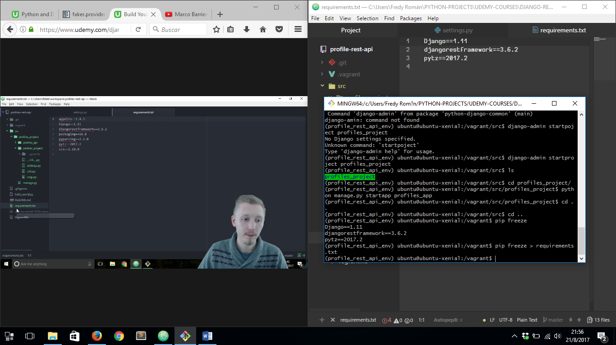

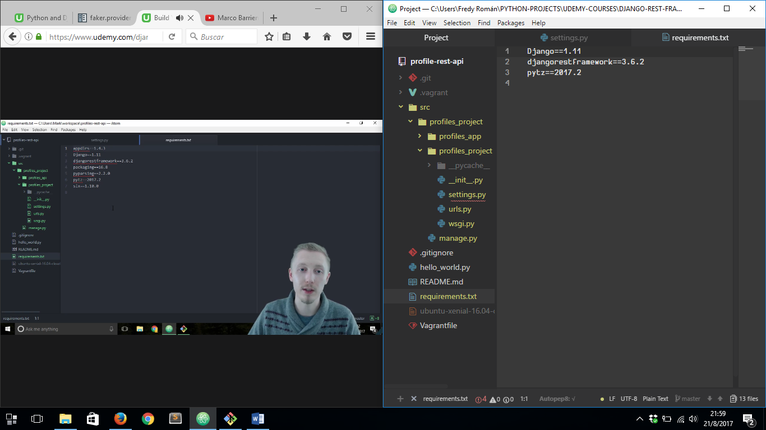

SO WHEN WE NEED WE COULD INSTALL OUR SERVER WITH ALL OF THOSE PACKAGES LISTED IN OUR ***requirements.txt*** FILE

DON´T FORGET TO MAKE COMMIT OF ALL CHANGES DONE IN OUR PROJECT.